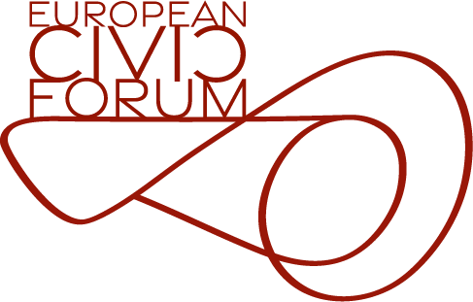

Call for applications: 2023 Re-granting

As of 2023, framework partners within the CERV Programme that qualify as European networks have the possibility to re-grant (i.e., further disburse grants/financial support to third parties) to their member organisations. The overall CERV budget for regranting in 2023 amounts to 5,8 mil in addition to the annual amount of a framework partner organisation budget. 80% co-financing rule applies to regranting as well.
The re-granting is an instrument of micro-financial support to civic groups, local initiatives, and movements in the European Union. The aim is to provide a flexible response and to strengthen capacity of member organisations in responding to societal and political challenges, but also build and sustain constituencies and engage in European network building and policies.

Please read the instructions carefully. Once you have completed the applications, send us the documents, together with your statutes at vsestovic@civic-forum.eu

Your organization
- Organization name

- Registered address

- Key contact person name and position

- Phone and email address

- Name and position of the authorized signatory

- Phone and email address

- Number of employees
Please tell us how many people are working in your organisation and their functions

- Links to website or social media content that cover your activities

Project summary
You are applying for
☐A Rapid support
☐ An Operational support
- Present briefly the content of your work, sources of financing, explaining what type of support you require from ECF

- Estimated timeline of your project
Please tell us when you would need to start your funded activities and when they would end

- Detailed description of the problem you aim to solve with ECF support

- Results you expect to achieve with the support
Please explain the results and impact that the funding will help you achieve (350 words max.)

- Total requested budget

